The Board of Trustees of Franklin Township, Franklin County, Ohio, met in person in a Special Meeting at 12:00 p.m. on Thursday, October 19, 2023. The Trustee marked below made a motion for the adoption of the following Resolution:

¨ Fleshman ¨ Leezer ¨ Horn

**WHEREAS** it is necessary to provide for the current expenses and other expenditures of Franklin Township, Franklin County, during the year ending December 31, 2023; and,

**WHEREAS** the Annual Appropriations Resolutions 2022-206 for the period from January 1, 2023, through December 31, 2023, needs to be amended.

**NOW, THEREFORE, BE IT RESOLVED BY THE BOARD OF TOWNSHIP TRUSTEES OF FRANKLIN TOWNSHIP, FRANKLIN COUNTY:**

**SECTION 1,** the sums presented in ***Exhibit A***, hereto attached, be, and the same is hereby set aside and appropriated for the several purposes for which expenditures are to be made for and during the year ending December 31, 2023.

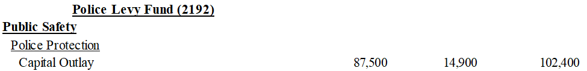

**SECTION 2,** the amount presented below be reallocated as follows:



**SECTION 3.** That all formal actions of this Board concerning and relating to the adoption of this Resolution were passed in an open meeting of this Board, and that all deliberations of this Board and any of its committees that resulted in such formal action were in meetings open to the public, in compliance with all legal requirements including Section 121.22 of the Ohio Revised Code.

**SECTION 4**. That this Resolution shall be in full force and effect immediately upon its adoption.

*The following Trustee marked below seconded the motion:*

¨ Fleshman ¨ Leezer ¨ Horn

*Roll was called for the adoption of the Resolution, and the vote was as follows:*

**Fleshman:** ¨ YES/ ¨ NO **Leezer:** ¨ YES/ ¨ NO **Horn:** ¨ YES/ ¨ NO

___________________________

Trustee John Fleshman

___________________________

Trustee James Leezer

*Attested to on this 19th day of October 2023* ___________________________

Trustee Ralph Horn

*_______________________________*

*Fiscal Officer, Linzie Justus*

*Fiscal Department*